# We will Deploy 4 VMs on AWS using Makefile

**To run the makefile:**

* Define necessary variables:

AWS_PROFILE = default

REGION = us-east-1

INSTANCE_TYPE = t2.micro

AMI_ID := $(shell aws ec2 describe-images --owners amazon --filters "Name=architecture,Values=x86_64" "Name=root-device-type,Values=ebs" "Name=virtualization-type,Values=hvm" --query "Images[0].ImageId" --output text)

* Create key-pair

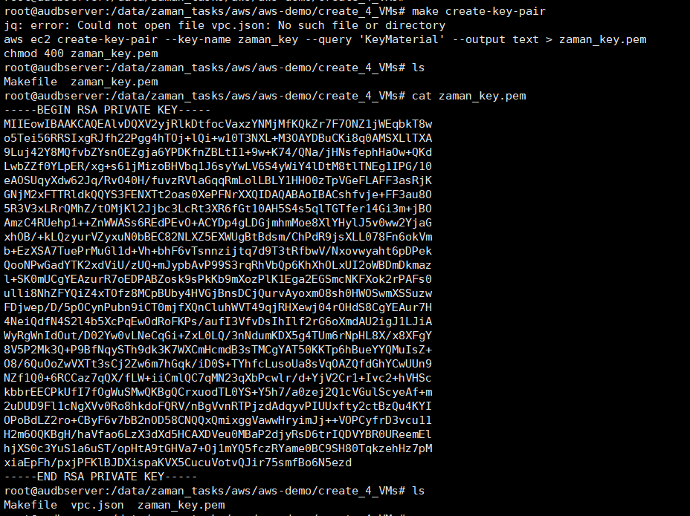

* Copy previous generated vpc.json file in this directory
* Get subnet id and create VM-1

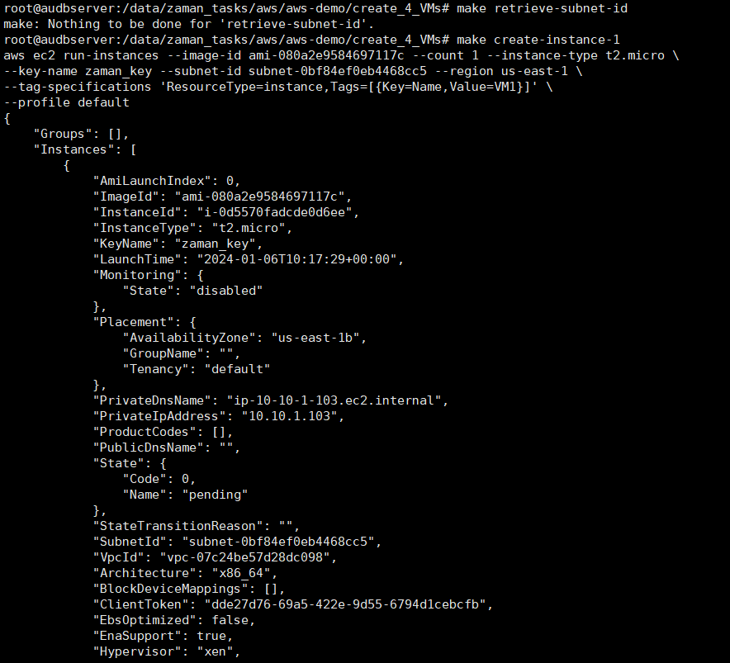

* Similarly create other VMs

make create-instance-2

make create-instance-3

make create-instance-4

